ModelMuse with Support for PEST – Beta 7

# Summary

* ModelMuse can use PEST to calibrate boundary conditions.
* User defined data sets can be specified via PEST parameters and then used in defining data sets.

# Applying PEST Parameters to Boundary Conditions

The Object Properties dialog box has been modified to allow the user to specify PEST parameters. In previous versions of ModelMuse the pane for each boundary condition or model feature allowed the user to specify different values for different times. For example, The pane for the Drain package looked like the figure below.

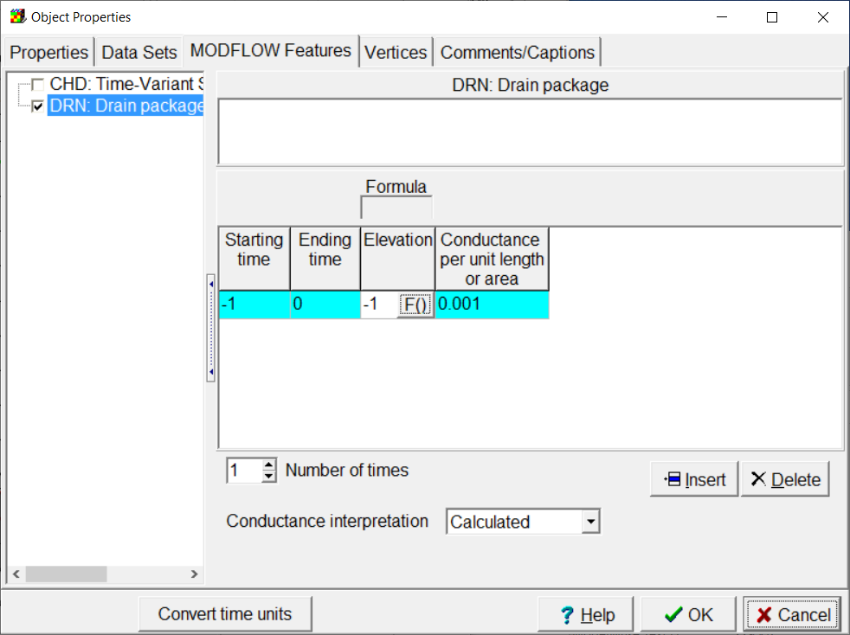

In the latest beta release two new rows have been inserted just below the caption row. Now the pane looks like the figure below.

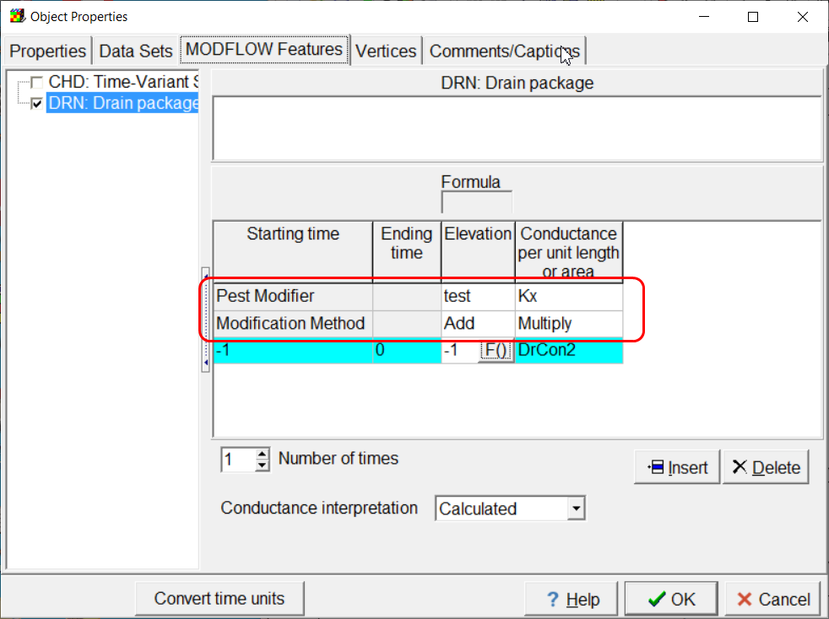

The two new rows are labeled “PEST Modifier” and “Modification Method”. If the user selects a cell in the PEST Modifier row, they can select either a PEST parameter or a data set whose values are specified via PEST parameters. The parameter or data set will be used to modify the values specified in the column. Its value can either be added or multiplied by the value for a particular time to specify the value for that time.

In the example above, there are two PEST Modifiers: “test” and “Kx”. Both the PEST Modifiers happen to both be data sets that will be updated by PEST. When PEST runs the model, the first thing that will happen is that PEST will run a PLPROC scripts that will write updated values of the data sets. If there were any data sets used as the formulas for individual times, those would be updated in the same way. Next PEST will run EnhancedTemplateProcessor with a template for the Drain file input. The template will access the updated values of the data arrays and updated parameter values. In this case, one PEST parameter is used: “DrCon2.” These updated values will be substituted into formulas for the drain elevation and conductance.

One thing that is important to remember is that the formula for a particular time will be estimated if it is either the name of a parameter or a data set that is estimated by PEST but it won’t be estimated if it just USES a data set that is a estimated by PEST. For example , if a data set name “MyDataSet” is estimated by PEST it won’t work to set the formula for a boundary condition to “MyDataSet + 1.” That will be interpreted as an ordinary formula by ModelMuse and the value calculated by ModelMuse will not be updated by PEST.

Anther thing to remember is that when PEST is updating data set values, it does so only by substituting parameter values or interpolating by pilot points. The updated value generated by PEST will not be affected by the formula specified for the data set within ModelMuse.

In the above example, two different input variables will be estimated by PEST, the drain elevation and the drain conductance. This was done for the purposes of illustration but estimating both might not be a good idea. It is possible that a change in one of them could be offset by a change in the other. This could prevent PEST from estimating a unique value for either one of them. Similarly, the conductance is affected by two things that will be both estimated by PEST: Kx and DrCon2. Changes in either one could offset changes in the other making it impossible for PEST to provide unique estimates for either. This new capability in ModelMuse is a tool that can help the user calibrate a model but a unique calibration may not be possible if the tool is used unwisely.